

**Touchstones**

***Netcards***

**Worth & Dignity Netcards with Text**

Creative Life HRJ

Democracy HRJ

Deserving HRJ

Discount HRJ

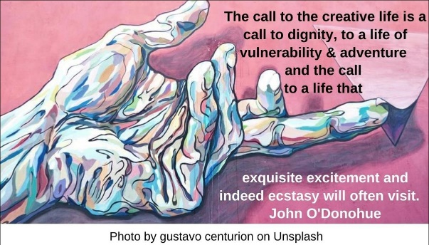

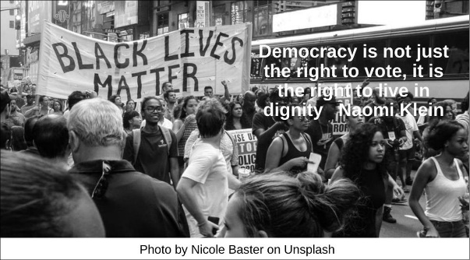

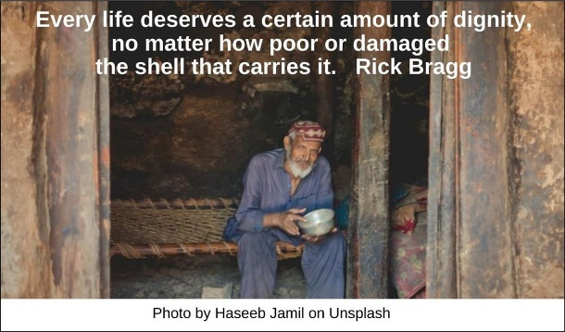

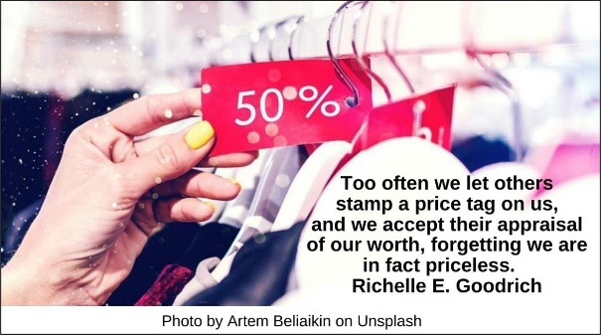

Essential HRJ

Every Second HRJ

Flight HRJ

Gap HRJ

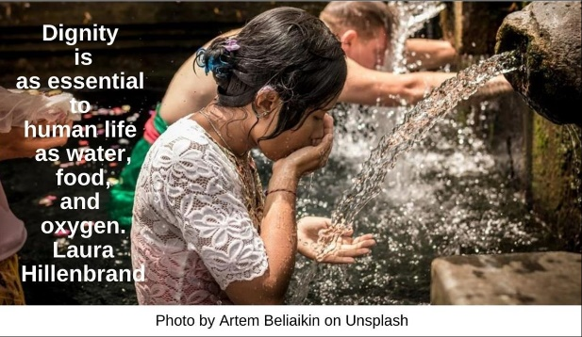

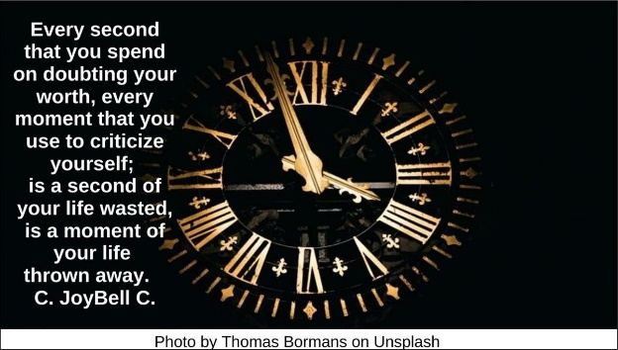



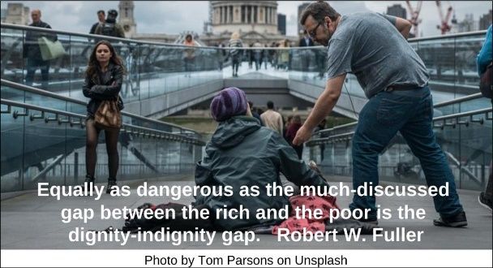

Identity HRJ

Imperfect HRJ

Imperfection HRJ

Just Like Us HRJ

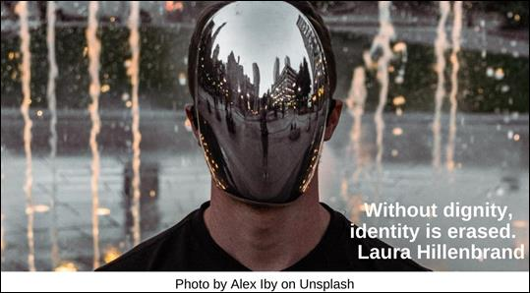

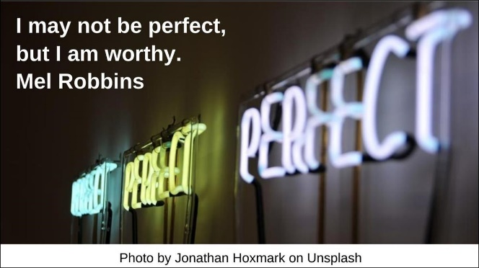

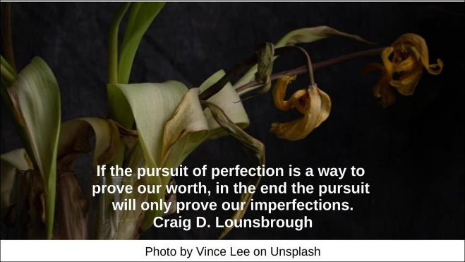

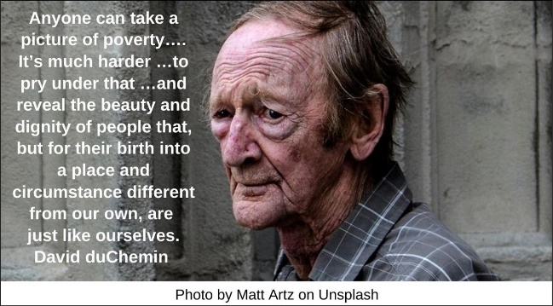

Loss HRJ

Lotus HRJ

Mirror HRJ

Money HRJ

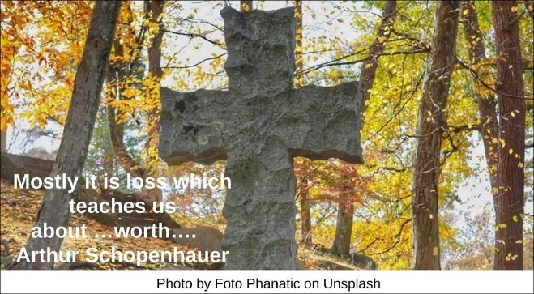

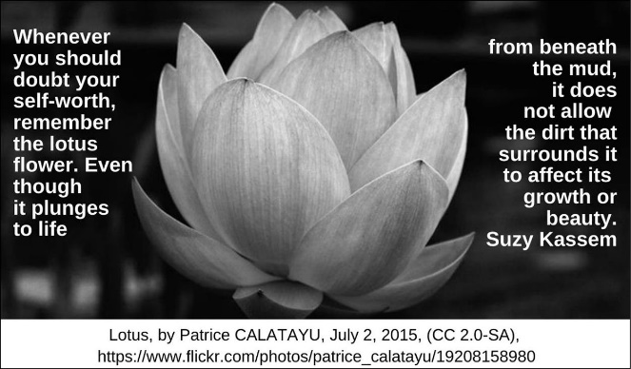

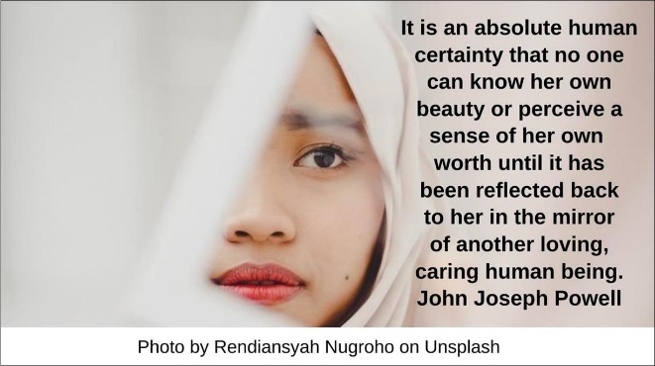

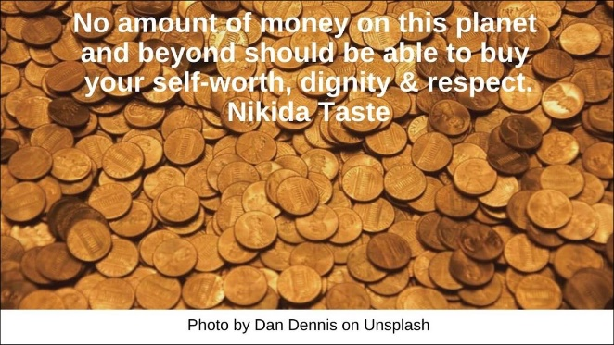

More HRJ

Net-worth HRJ

Never HRJ

No compromise HRJ

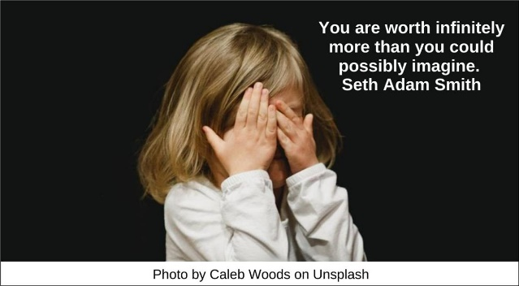

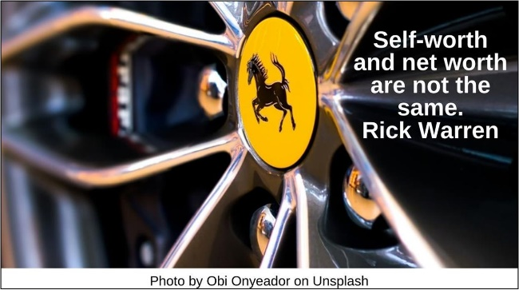

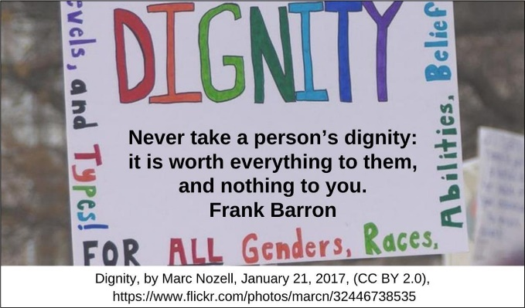

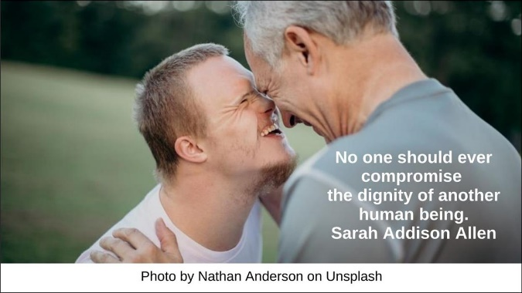

Poverty HRJ

Quantify HRJ

Reflection HRJ

Retains a dignity HRJ

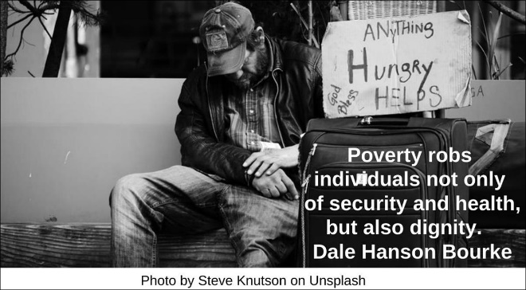

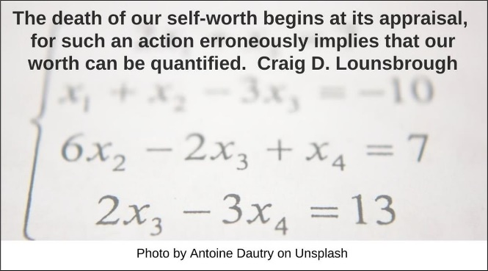

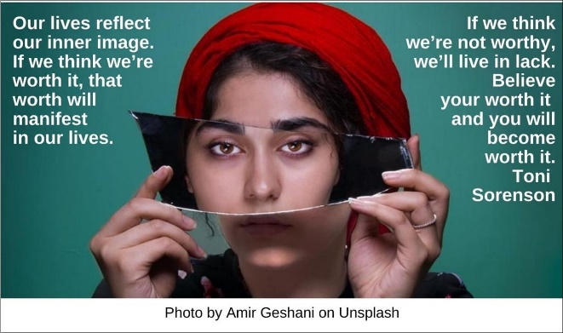

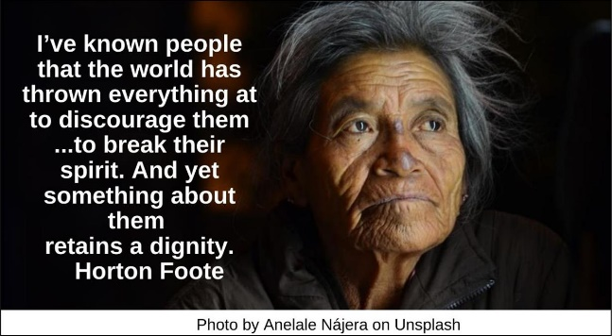

Scale HRJ

Seeking HRJ

Sorry HRJ

Stand HRJ

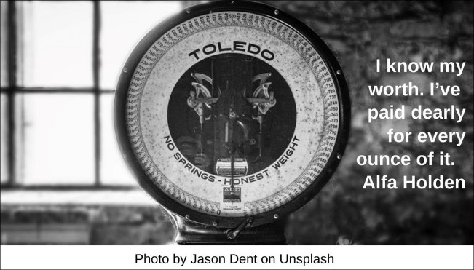

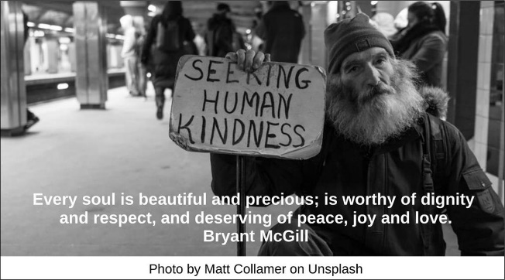

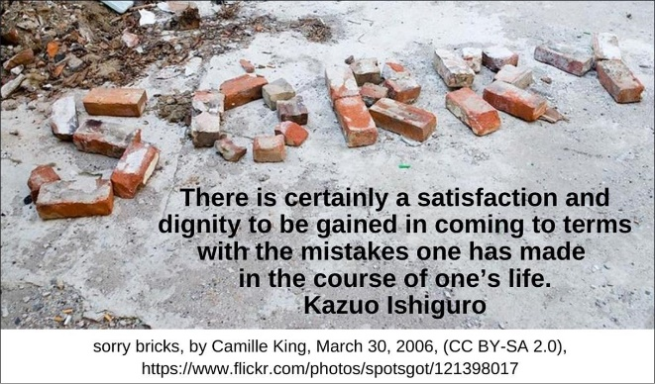

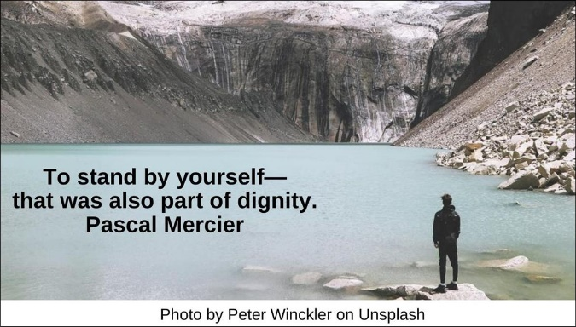

Suffering HRJ

True about you HRJ

Truth HRJ

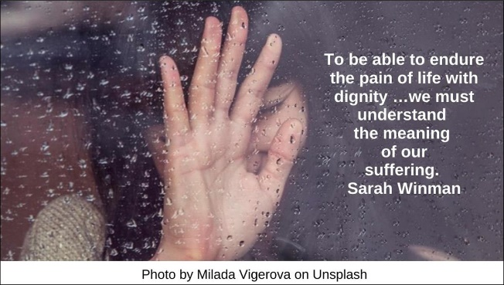

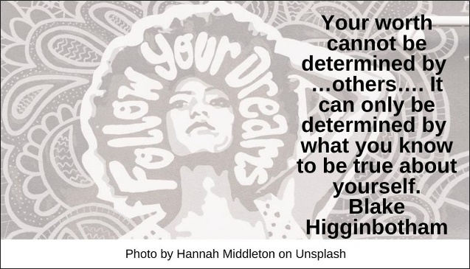

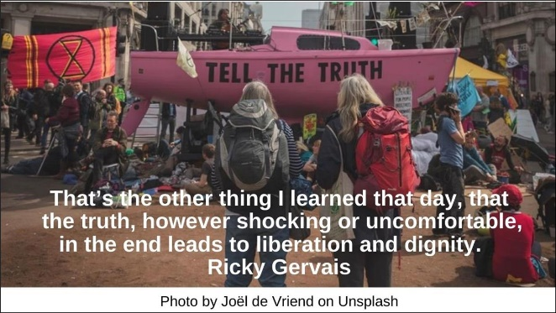

**Text of Quotes**

Creative Life HRJ

The call to the creative life is a call to dignity, to a life of vulnerability and adventure and the call to a life that exquisite excitement and indeed ecstasy will often visit. John O'Donohue

Democracy HRJ

Democracy is not just the right to vote, it is the right to live in dignity Naomi Klein

Deserving HRJ

Every life deserves a certain amount of dignity, no matter how poor or damaged the shell that carries it. Rick Bragg

Discount HRJ

Too often we let others stamp a price tag on us, and we accept their appraisal of our worth, forgetting we are in fact priceless. Richelle E. Goodrich

Essential HRJ

Dignity is as essential to human life as water, food, and oxygen. Laura Hillenbrand

Every Second HRJ

Every second that you spend on doubting your worth, every moment that you use to criticize yourself; is a second of your life wasted, is a moment of your life thrown away. C. JoyBell C.

Flight HRJ

Every woman that finally figured out her worth, has picked up her suitcases of pride and boarded a flight to freedom, which landed in the valley of change. Shannon L. Alder

Gap HRJ

Equally as dangerous as the much-discussed gap between the rich and the poor is the dignity-indignity gap. Robert W. Fuller

Identity HRJ

Without dignity, identity is erased. Laura Hillenbrand

Imperfect HRJ

I may not be perfect, but I am worthy. Mel Robbins

Imperfection HRJ

If the pursuit of perfection is a way to prove our worth, in the end the pursuit will only prove our imperfections. Craig D. Lounsbrough

Just Like Us HRJ

Anyone can take a picture of poverty…. It’s much harder …to pry under that …and reveal the beauty and dignity of people that, but for their birth into a place and circumstance different from our own, are just like ourselves. David duChemin

Loss HRJ

Mostly it is loss which teaches us about …worth…. Arthur Schopenhauer

Lotus Flower HRJ

Whenever you should doubt your self-worth, remember the lotus flower. Even though it plunges to life from beneath the mud, it does not allow the dirt that surrounds it to affect its growth or beauty. Suzy Kassem

Mirror HRJ

It is an absolute human certainty that no one can know his own beauty or perceive a sense of his own worth until it has been reflected back to him in the mirror of another loving, caring human being. John Joseph Powell

Money HRJ

No amount of money on this planet and beyond should be able to buy your self-worth, dignity & respect. Nikida Taste

More HRJ

You are worth infinitely more than you could possibly imagine. Seth Adam Smith

Net-worth HRJ

Self-worth and net worth are not the same. Rick Warren

Never HRJ

Never take a person’s dignity: it is worth everything to them, and nothing to you. Frank Barron

No compromise HRJ

No one should ever compromise the dignity of another human being. Sarah Addison Allen

Poverty HRJ

Poverty robs individuals not only of security and health, but also dignity. Dale Hanson Bourke

Quantify HRJ

The death of our self-worth begins at its appraisal, for such an action erroneously implies that our worth can be quantified. Craig D. Lounsbrough

Reflection HRJ

Our lives reflect our inner image. If we think we’re worth it, that worth will manifest in our lives. If we think we’re not worthy, we’ll live in lack. Believe your worth it and you will become worth it. Toni Sorenson

Retains a dignity HRJ

I’ve known people that the world has thrown everything at to discourage them...to break their spirit. And yet something about them retains a dignity. Horton Foote

Scale HRJ

I know my worth. I’ve paid dearly for every ounce of it. Alfa Holden

Seeking HRJ

Every soul is beautiful and precious; is worthy of dignity and respect, and deserving of peace, joy and love. Bryant McGill

Sorry HRJ

There is certainly a satisfaction and dignity to be gained in coming to terms with the mistakes one has made in the course of one’s life. Kazuo Ishiguro

Stand HRJ

To stand by yourself—that was also part of dignity. Pascal Mercier

Suffering HRJ

To be able to endure the pain of life with dignity …we must understand the meaning of our suffering. Sarah Winman

True about you HRJ

Your worth cannot be determined by …others…. It can only be determined by what you know to be true about yourself. Blake Higginbotham

Truth HRJ

That’s the other thing I learned that day, that the truth, however shocking or uncomfortable, in the end leads to liberation and dignity. Ricky Gervais